<<Customer Logo>>

[CUSTOMER NAME – SYSTEM NAME]
Requirement Specifications
For <<App Name>>

Version: 0.7

Singapore, April 2014
Approval Page
The endorsement on this document by authorized [Customer Name] representative indicates [Customer Name] and FPT‟s agreement on the “[Project Name] Requirement Specifications” document.

Prepared by : | (FPT)  Business Analyst | Signature: | ____________________
 |  | Date: | ____ /____ / ____
Reviewed by : | (FPT)  Project Manager | Signature: | ____________________
 |  | Date: | ____ /____ / ____
Supported by: | (Customer Name) | Signature: | ____________________
 |  | Date: | ____ /____ / ____
Approved by : | (Customer Name) | Signature: | ____________________
 |  | Date: | ____ /____ / ____

Revision History
Date | Version | Author | Change Description
DD/MM/YYYY | 0.5 | Author | First Creation
 | 0.7 |  | For internal review
 | 0.8 |  | For the first release to customer
 | 0.9.x |  | For updating version while reviewing with customer
 | 1.0 |  | For official sign-off

Table of Contents

1. Introduction 5
1.1 Purpose 5
1.2 Overview 5
1.3 Intended Audience and Reading Suggestions 5
1.4 Abbreviations 5
1.5 References 6
2. High Level Requirements 7
2.1 Object Relationship Diagram 7
2.2 Workflow 8
2.3 State Transition 9
2.4 Use Case Diagram 10
2.5 Permission Matrix 12
2.6 Site Map 13
3. Use Case Specifications 15
3.1 Manage Use case 15
3.1.1 UC 1: Mange Company 15
3.1.2 UC 2: Create a new Request 17
3.1.3 UC 3: View an existing Request 18
3.1.4 UC 4: Search Requests 19
3.1.5 UC 5: Update an existing Request 21
3.1.6 UC 6: Delete an existing Request 23
3.2 Workflow Use case 26
3.2.1 UC 7: Submit a Request 26
3.2.2 UC 8: Approve a Request 27
3.2.3 UC 9: Reject a Request 29
3.3 Other Use case 32
3.3.1 UC 10: Scheduled Job (E.g. Send email Reminder) 32
3.4 Common Business Rules 33
4. Mockups Screen 34
4.1 Landing Page 34
4.2 Detail Screen 34
4.3 Listing View 35
5. Non-Functional Requirements 36
5.1 Performance Requirements (optional) 36
5.2 Safety Requirements (optional) 37
5.3 Security Requirements (optional) 37
5.4 Software Quality Attributes (optional) 38
6. Other Requirements 40
6.1 Common field controls 40
6.2 Common Messages Configuration 40
6.3 View Columns Display 41
6.4 Pagination 41
6.5 Search Component 42
6.6 Bulk Action 42
7. Integration 44
8. Data Migration 44
8.1 Migration Scope 44
8.2 Data Mapping 44
9. Appendices 45
9.1 Messages List 45
9.2 Email Templates 46

Introduction

Purpose
The Functional Requirements Specification will:
- Define the scope of business objectives, business functions, and organizational units covered,
- Identify the business processes that the solution must facilitate,
- Facilitate a common understanding of what the functional requirements are for all parties involved,
- Establish a basis for defining the acceptance tests for the solution to confirm that what is delivered meets requirements.
The purpose of the document is to collect and analyse all assorted ideas that have come up to define the system, its requirements with respect to consumers. Also, we shall predict and sort out how we hope this product will be used in order to gain a better understanding of the project, outline concepts that may be developed later, and document ideas that are being considered, but may be discarded as the product develops.

Overview
<Describe the purpose & scope of the system>

Intended Audience and Reading Suggestions
This document is intended for:
- Development team: Responsible for developing detailed design, implement and perform unit test, integration test and system test for the migrated application
- Data Migration team: Responsible for creating data migration scripts, and perform data migration for the application.
- Documentation Team: Responsible for writing User Guide for the application.
- UAT team: Responsible for conducting user acceptance test sessions with end users.

Abbreviations
<Template only: List out all Acronym used in this documents and sort them alphabetically.>

Acronym | Reference
SRS | System Requirement Specification
UC | Use Case
BR | Business Rules
CBR | Common Business Rules
ET | Email Template
N/A | Not Applicable or Not Available
MSG | Message
[Field] | Convention for mentioning a field
<<Field>> | Convention for value of this field, specifically use in the context of Email Template
“Text Value” | Convention for mentioning a value
<Value> | Convention for mentioning special value, i.e. <Today>, <Current User>
TBU | To be Updated
NRF | National Research Foundation
OOE | Other Operating Expenditure

References
<Template only: List any other documents or Web addresses to which this SRS refers. These may include user interface style guides, contracts, standards, system requirements specifications, use case documents, or a vision and scope document. Provide enough information so that the reader could access a copy of each reference, including title, author, version number, date, and source or location.
List any version information relating to external Tools, Plugins or Platforms that the system uses or is built upon.
If no, put N/A>

Title | Reference | Description
Title of Document / Website | Link to the Document or Website | Description of the purpose or information provided by the Document, Website.
Title of Tools, Plugins or Platforms | Link to the Tools, Plugins or Platforms Website. | Version information of the Tools, Plugins or Platforms that the systems uses or is built upon.

High Level Requirements
This section describes the general overview of the system functions or business processes which are depicted in different diagrams. It shows the types of users, their granted permissions to perform specific system functions and the sequence required to complete a business workflow (if any). As the section name implies, it is high-level which means not detailed enough. For detailed requirement specification, please see Use Case Specifications section below.

Context Diagram
This section shows the static relationship between each object in the system. An object could be described as an instance of a particular entity in the system. For example, “Booking Request Form” is an object in this system which holds its own information, such as: Requestor Details, Resource, Equipment, Booking Date Time…

Figure 1:

Object Description:
# | Object | Description
Object
1 | NRF | <Purpose of this object, what kind of information storing in this object>
2 | OOE
Actor
1 | NRF | <Responsibility of people in this group>  <How to recognize user in this group? E.g. person in SharePoint group, selected person in a field abc>
2 | OOE
External System
1 | SAP | <Purpose of this system, how to integrate to this system>
2

Workflow
This section shows the flow of tasks or steps taken by each user of the system in order to complete a business process. The user’s actions are shown in each business process stage of the system along with the conditions under which it can move to the next stage or revert to the previous.

Figure 2:
Workflow Explanation:
<Can remove this section for simple workflow>

State Transition
This represents the behavior of the system in response to user’s actions by changing state of data objects. The circle shows the state. The line that connects one state to another shows the action required for that state change to happen. These actions are usually triggered by a user.

Figure 3:

Permission Matrix
Permission Matrix mapping functions and user roles for <<App Name>> application is described as below:
Remark:
“O” means that user has permission on corresponding function. For more information about what the actor can do on that function, please refer to corresponding use case.
“O*” means that user has permission on corresponding function on the item they created. For more information about what the actor can do on that function, please refer to corresponding use case.
“X” means that user does not have permission on corresponding function.
 | Actor 1 | Actor 2
Function 1
Function 2
e.g.
 | General Users |  |  |  | SSS Admin | System Admin | System Timer
 | Suggester | Evaluator | Commenter | Implementer
Suggestion
Save Suggestion as Draft | O | X | X | X | O | O | X
Submit Suggestion | O | X | X | X | O | O | X
Status is “Draft” | X | X | X | X | X | X | X
View Suggestion | O* | X | X | X | O* | O* | X
Update Suggestion | O* | X | X | X | O* | O* | X
Delete Suggestion | O* | X | X | X | O* | O* | X
Submit Suggestion | O* | X | X | X | O* | O* | X
Status is “For Evaluation” | X | X | X | X | X | X | X
View Suggestion | O | O | O | O | O | O | X
Update Suggestion | X | O* | X | X | O | X | X
Route back to Suggester | X | O* | X | X | O | X | X
Forward to another Evaluator | X | O* | X | X | O | X | X
Forward to Commenter | X | O* | X | X | O | X | X
Support Suggestion | X | O* | X | X | O | X | X
Not support Suggestion | X | O* | X | X | O | X | X
Close Suggestion | X | X | X | X | O | X | X
Delete Suggestion | X | X | X | X | X | O | X
Search Suggestions | O | O | O | O | O | O | X
Generate General Reports | O | O | O | O | O | O | X
Generate Administrative Reports | X | X | X | X | O | O | X
Send Email Reminder | X | X | X | X | X | X | O

Site Map
The site map describes the way for navigating through the system.
<Template only: Note: Only need to draw up to 3 levels from the Home page to reduce the complexity and make the map readable.>
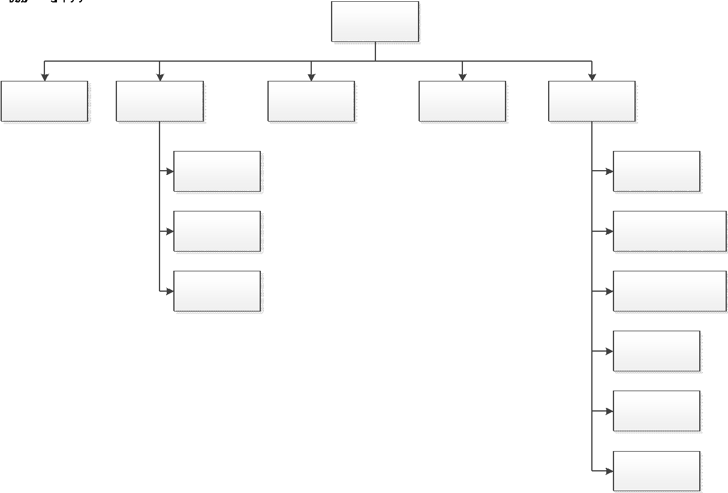

Figure 5:
Page | Description | Permission
Let’s submit | Link to the screen description | Who has permission to view this page
My Suggestions
…

Use Case Specifications
This section covers the system’s functional requirements which details what the system must do in terms of input, behavior and the expected output. It elicits the interaction between the actor(s) and the system, the system’s behavior and the results of their interactions.

Manage Use case

UC 1: Lập giao dịch gửi tiền
Objective: | Cho phép giao dịch viên lập giao dịch gửi tiền.
Actor: | User có role = “Giao dịch viên”  OR user có role = “Admin”
Trigger: | User click vào btn “Tạo GD” trên màn hình “tạo giao dịch gửi tiền”.
Pre-condition: | User đăng nhập thành công vào hệ thống và có quyền tương ứng.
Post-condition: | Lập giao dịch thành công
Activities Flow
Business Rules
Step | BR Code | Description
(2) | BR 1 | Quy tắc hiển thị  Hệ thống hiển thị màn hình “Tạo yêu cầu gửi tiền”.
(4) | BR 2 | Quy tắc kiểm tra  Hệ thống sẽ validate lần lượt theo các logic sau:  - Nếu các field bắt buộc = null, hệ thống sẽ hiển thị MSG 1 Vui lòng nhập thông tin  - Nếu [Sender Name] có số kí tự <2, hệ  - Nếu [Sender Phone] kí tự đầu <> “0” hoặc có độ dài > 10 kí tự số thì…  - Nếu [Amount] < 100.000 hoặc >100.000.000
(5) | BR 8 | Saving Rules:  Sau khi pass qua bước 4, hê thống thực hiện các logic sau:  - Save các thông tin vào DB  - Set [Transaction Code] theo logic {yyyymmddAAAAA}  - yyyy: là năm hiện tại  - mm: là tháng hiện tại  - dd: ngày hiện tại  - AAAAA là số giao dịch được tính bởi ID mới nhất + 1  VD: 2025081400001  - Set [Status] = “Submitted”  - Show toast msg MSG2  - Gửi email cho người phê duyệt {dddđ} theo ET1  - Redirect user về màn hình danh sách giao dịch

US: Lập giao dịch gửi tiền
Với vai trò là giao dịch viên
Tôi mong muốn có chức năng “Lập giao dịch gửi tiền”
Để Cho phép giao dịch viên lập giao dịch gửi tiền.
AC
- Khi user click vào nút thêm mới, hệ thống hiển thị màn hình “lập giao dịch gửi tiền”
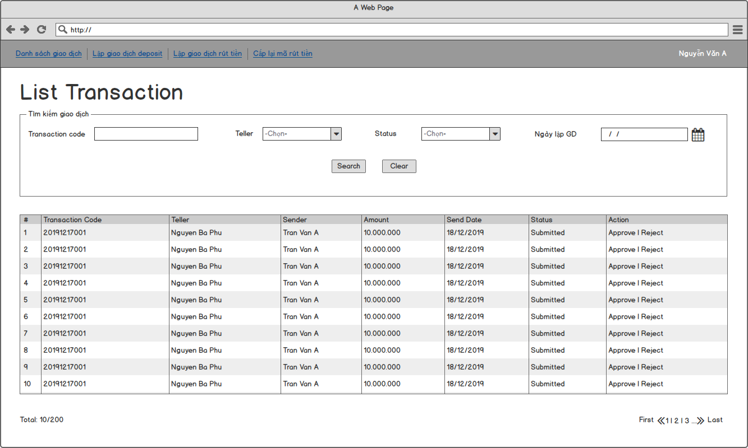
- Khi user nhập các thông tin và ấn save, hệ thống cần validate theo các logic sau
  - Ádasd
  - Âsd
  - Âsd
- Khi user ấn save và pass qua các logic hệ thống cần xử lý các logic sau
  - Ádasd
  - Ádasd
  - ádasd

UC 3: View an existing Request
Objective: | This use case allows user to view the details of a Request.
Actor: | All authenticated users
Trigger: | User selects to open an existing Request.
Pre-condition: | - User is logged in successfully as actor above.  - Ngày lập giao dịch - ngày hiện tại < 90 ngày
Post-condition: | The Request is opened for viewing.

Activities Flow

Business Rules
Step | BR Code | Description
(2) | BR 9 | Screen Displaying Rules:  The system will load the Request list view based on screen <<link to screen>>.

UC 4: Search Requests
Objective: | This use case allows user to search for existing requests.
Actor: | All authenticated users
Trigger: | User selects to search requests.
Pre-condition: | User is logged in successfully as actor above.
Post-condition: | Search Result is displayed.

Activities Flow
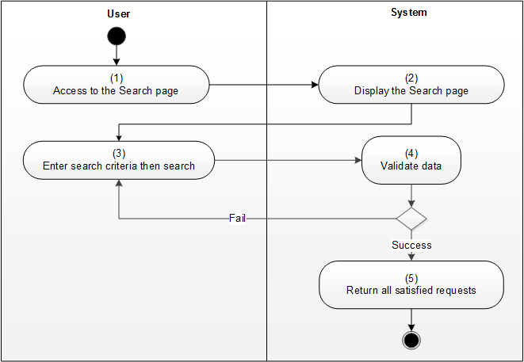

Business Rules
Step | BR Code | Description
(2) | BR 10 | Screen Displaying Rules:  The system will load Request searching screen <<link to screen>>.
(4) | BR 11 | Validating Rules:  The system will check at the time of searching requests:  - In case both From Date and To Date of Date Submitted are inputted, if [From Date] is later than [To Date], system will show error message MSG 8 Invalid Date combination.
(5) | BR 12 | Searching Rules:  - When user clicks Search button, system will retrieve all requests which satisfy all following conditions:  - If user does not enter any criteria, system will show all Requests on the result view.  - If user enter any criteria, system will show all returned Requests as per following table:  # Searching Condition Searching Result  If the [Requester] field is blank System will retrieve all records without filtering by Requester’s Name. Otherwise, filter only records whose Requester’s Name matches inputted [Requester].  If the [Request Title] field is blank System will retrieve all records without filtering by Request Title. Otherwise, filter only records whose Request Title matches inputted [Request Title].  If the [Request Type] field is “All” System will retrieve all records without filtering by Request Type. Otherwise, filter only records whose Request Type matches inputted [Request Type].  If the [Status] field is “All” System will retrieve all records without filtering Status. Otherwise, filter only records whose Status matches inputted [Status].  <<insert more search condition>>  - In case there is no item matches the search criteria, system displays an message MSG 9 No information found! on the Search Results view. Otherwise, system shows all returned Requests on the result view.

UC 5: Update an existing Request
Objective: | This use case allows user to update an existing Request.
Actor: | All authenticated users
Trigger: | User selects to edit an existing Request then selects to Save.
Pre-condition: | - User is logged in successfully as actor above.  - If the current request is a Draft, the current user = Requester or Application Admin.  - If the current request is Pending Approval, the current user = Requester, Approver or Application Admin.
Post-condition: | The Request is updated successfully.

Activities Flow

Business Rules
Step | BR Code | Description
(2) | BR 13 | Screen Displaying Rules:  The system will load Request screen <<link to screen>>.
(4) | BR 14 | Validating Rules:  Depending on the current status of the Request at the point of editing, system will validate based on the existing rules Requested under each of the use-case.  The validation logic is:  - The Request’s status is “Draft” and the Requester is working on it, system will perform following validation rules:  - If the value of any mandatory fields is blank, system will show an error message for the required fields as MSG 1 You must specify a value for this required field.  - <<Other validation rules>>  - The Request’s status is “Pending Approval”, system will perform following validation rules:  - System will show an error message for the required fields as MSG 1 You must specify a value for this required field. if the value of any mandatory and any of following fields are blank:  - [Final Approver].  - [Implementer].  - <<Other validation rules>>
(5) | BR 15 | Updating Rules:  - Save all changes.  - Append a new line in the [Routing History]:  <<Current date time>> - “Updated by” <<Current user’s name>>

UC 6: Delete an existing Request
Objective: | This use case allows user to delete a Request.
Actor: | All authenticated users
Trigger: | User selects to delete a Request
Pre-condition: | - User is logged in successfully as actor above.  - If the current Request is a Draft, current user = Requester, System Admin or Application Admin.  - If the current Request is in any status other than “Draft, current user = Application Admin.
Post-condition: | The selected Request is deleted successfully.

Activities Flow
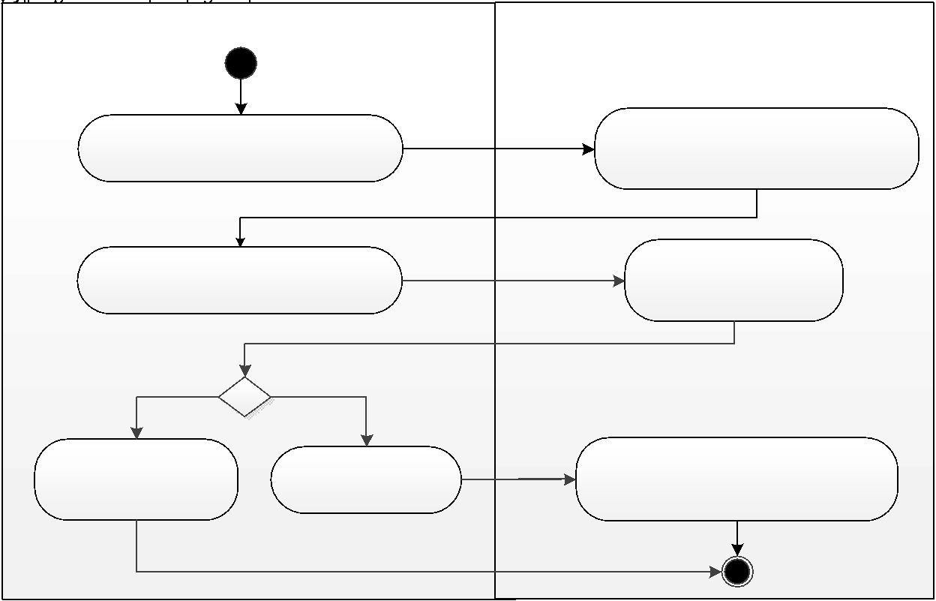

Business Rules
Step | BR Code | Description
(4) | BR 16 | Confirmation Message Rules:  The system shows confirmation message MSG 7 Are you sure you want to delete this item?
(6) | BR 17 | Deleting Rules:  - If user clicks on the “OK” button from the confirmation dialog, system will move the selected Request to the Recycle Bin/flag the document as deleted/delete the request permanently.  - If user clicks on the “Cancel” button, system will close the confirmation dialog and do nothing.

Workflow Use case

UC 7: Submit a Request
Objective: | This use case allows user to submit (or re-submit) a Request.
Actor: | - Requester  - Application Admin
Trigger: | User selects to submit a Request.
Pre-condition: | - User is logged in successfully as actor above.  - Request’s Status = “Draft” or “Rejected”.
Post-condition: | A Request is submitted successfully.

Activities Flow

Business Rules
Step | BR Code | Description
(2) | BR 18 | Screen Displaying Rules:  The system will load Request screen <<link to screen>>
(4) | BR 19 | Validating Rules:  The system performs the following validation:  - If the value of any mandatory fields is blank, system will show an error message for the required fields: MSG 1 You must specify a value for this required field.  - <Other validation rules that required specifically for submission function>
(5) | BR 20 | Submitting Rules:  - After all validation rules are passed, system performs the following actions  - Save all changes.  - Update [Status] to “Pending Approval”  - Update [Date Submitted] to the current date.  - Update [Submitted By] to the current user.  - Append a new line in the [Audit Trail]:  <<Current date time>> - “Submitted by ” <<Current user>>  - Show a confirmation message “Your request is submitted successfully.”
(5) | BR 21 | Email Notification Rule:  The system sends an email notification email according to the following template:  - Submit request: ET1  - Re-submit request: ET 1: Sending email to Evaluator when Suggester submits a Suggestion.

UC 8: Approve a Request
Objective: | This use case allows user to approve a Request.
Actor: | - Approver  - Application Admin
Trigger: | User selects to approve a Request.
Pre-condition: | - User is logged in successfully as actor above.  - [Status] is “Pending Approval”.
Post-condition: | A Request is approved and pending for implementation.

Activities Flow

Business Rules
Step | BR Code | Description
(2) | BR 22 | Screen Displaying Rules:  The system will load Request screen <<link to screen>>.
(4) | BR 23 | Validating Rules:  - System will show an error message as MSG 1 You must specify a value for this required field. if any of following fields is blank:  - [Remark from Approver]  - [Expected Date of Implementation]  - [Implementer]  - Any mandatory fields  - System will show a confirmation message as <TBU> if validation was successful.
(6) | BR 24 | Approval Rules:  After user clicks on “OK” button, system performs the following actions  - Save all changes.  - Update [Status] to “Approved”  - Update [Date Approved] to the current date.  - Update [Approved By] to the current user.  - Append a new line in the [Audit Trail]: <<Current date time>> - “Approved by ” <<Current user>>
(6) | BR 25 | Email Notification Rule:  The system sends an email notification based on email template <TBU>.

UC 9: Reject a Request
Objective: | This use case allows user to reject the Request.
Actor: | - Approver  - Application Admin
Trigger: | User selects to reject the Request.
Pre-condition: | - User is logged in successfully as actor above.  - [Status] is “Pending Approval”.
Post-condition: | A Request is rejected.

Activities Flow
Business Rules
Step | BR Code | Description
(2) | BR 26 | Screen Displaying Rules:  The system will load Request screen <<link to screen>>.
(4) | BR 27 | Validating Rules:  - System will show the error message MSG 1 You must specify a value for this required field. under field [Reason for Rejecting] if it is blank.  - System will show a confirmation message as <TBU> if validate successfully.
(6) | BR 28 | Rejecting Rules:  Upon user selecting to reject the current request, the system perform the following processing:  - Save all changes.  - Update [Status] to “Rejected”  - Update [Date Rejected] to the current date.  - Update [Rejected By] to the current user.  - Append a new line in the [Audit Trail]: <<Current date time>> - “Rejected by ” <<Current user>>
(6) | BR 29 | Email Notification Rule:  The system sends a notification email based on the following email template <TBU>

Other Use case

UC 10: Scheduled Job (E.g. Send email Reminder)
Objective | This use case allows System to send email reminder.
Actor | System
Trigger | At 02:00 AM Daily
Pre-conditions | N/A
Post-condition | Email reminders for appropriate requests are sent.

Activities Flow
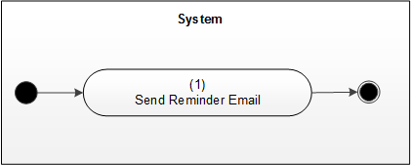
Business Rules
BR Code | Description
BR 30 | Sending Notification Email Rule: Tasks that need to be done by [Assigned To]:  System sends notification email for the Request under following conditions:  - [Status] of To Do Request is not equal to "Done”  - Today date is less than [Due by]  Using the following email template: <TBU>
BR 31 | Sending Notification Email Rule: Overdue Approval Requests  System sends notification email for the Request under following conditions:  - [Status] of Request is equal to "Pending for Approval”  - Today date is greater than [Expected Deadline]  Using the following email template: <TBU>

Common Business Rules
This section defines business rules that are used across use cases and can be considered as common rules. Each common business rule below is applied only for use cases that have reference to it.
BR Code | Description
CBR1

Mockups Screen
This section contains the screens and their respective attributes associated with one or more use cases defined in Use Case Specifications section above.

Landing Page
<Purpose of this screen & How to access>
<Screenshot>
Screen 1: <Screen Name>
# | Component | Description
1 | Left menu | <Describe all links in the left menu>
2 | Main Content | <Default view?>
3

Detail Screen
<Purpose of this screen & How to access>
<Screenshot for Read Mode>
Screen 2: <Screen Name>
<Screenshot for Edit Mode>
Screen 3: <Screen Name>
# | Component | Comp. Type | Editable | Mandatory | Default Value | Description
1 | Title | Singe Line of Text |  | Yes |  | Example:  - Purpose of this field if just the name is not enough to describe.  - This is read-only field. (Doesn’t need to mention if this is editable field)  - Date time format e.g. DD/MM/YYYY HH:mm
2 |  | Multiple Line of Text
3 |  | Drop Down List
4 |  | Radio Button
5 | Submit | Button |  | N/A |  | This button triggers UC 1 (Need a cross reference to the UC).

Listing View
<Purpose of this screen & How to access>
<Screenshot for view>
Screen 4: <Screen Name>
# | Component | Value | Description
1 | Title | [Title] | - Link to item  - Grouping and sorting ascending
2
3
4 | Submit | Button | To submit selected item(s). Refer to UC …

Non-Functional Requirements
This section describes the operation of the system with respect to the Use Case Specifications section (Functional requirements). This comprises mostly of the technical architecture of the system which could be referred to as the quality of the system.

Performance Requirements (optional)
< Template only: If there are performance requirements for the product under various circumstances, state them here and explain their rationale, to help the developers understand the intent and make suitable design choices. Specify the timing relationships for real time systems. Make such requirements as specific as possible. You may need to state performance requirements for individual functional requirements or features.>

Performance requirements refer to the capability of the software to provide the required performance relative to the amount of resources used, under stated conditions
Title | Variables / Criteria | Remarks
Response Time | - Measurement Point.  - Statistic Type.  - Measurement Period.  - Platform.  - Error Rate. | i.e. Number of operations performed per second.  i.e. The system shall be able to process 100 payment transactions per second in peak load  i.e. Production of a simple report shall take less than 20 seconds for 95% of the cases.  i.e. Scrolling one page up or down in a 200 page document shall take at most 1 second.
Workload | - Workload percentage at peak time.  - Workload percentage at off-peak time. | i.e. In standard workload, the CPU usage shall be less than 50%, leaving 50% for background jobs.
Scalability | Ease of Scalability.
Platform | - Hardware.  - Software.  - External System Integration. | - Operating systems:  - Windows: latest + 2 previous versions.  - Mac OS: latest + 2 previous versions.  - Devices:  - Mobile.  - Tablet.  - Desktop.

Safety Requirements (optional)
<Template only: Specify those requirements that are concerned with possible loss, damage, or harm that could result from the use of the product. Define any safeguards or actions that must be taken, as well as actions that must be prevented. Refer to any external policies or regulations that state safety issues that affect the product’s design or use. Define any safety certifications that must be satisfied.>

Safety Requirement refers to the aspects of a solution that protects solution contents or solution components from accidental or malicious access, use, modification, destruction, or disclosure.

Title | Variables / Criteria | Remarks
Authenticity | Mode of authentication
Privacy | Password and message encryption | i.e. The system needs to follow standard encryption algorithm called DES (Data Encryption Standard).

Security Requirements (optional)
< Template only: Specify any requirements regarding security or privacy issues surrounding use of the product or protection of the data used or created by the product. Define any user identity authentication requirements. Refer to any external policies or regulations containing security issues that affect the product. Define any security or privacy certifications that must be satisfied.>

Title | Variables / Criteria | Remarks
Authentication | - Success rate in authentication.  - Resistance to known attacks.  - Probability/time/resources to detect an attack.  - Percentage of useful services still available during an attack.  - Percentage of successful attacks.  - Lifespan of a password, of a session.  - Encryption level. | i.e. The application shall identify all of its client applications before allowing them to use its capabilities.  i.e. The application shall ensure that the name of the employee in the official human resource and payroll databases exactly matches the name printed on the employee’s social security card.  i.e. At least 99% of intrusions shall be detected within 10 seconds.

Software Quality Attributes (optional)
< Template only: Specify any additional quality characteristics for the product that will be important to either the customers or the developers. Some to consider are: adaptability, availability, correctness, flexibility, interoperability, maintainability, portability, reliability, reusability, robustness, testability, and usability. Write these to be specific, quantitative, and verifiable when possible. At the least, clarify the relative preferences for various attributes, such as ease of use over ease of learning.>

Title | Variables / Criteria | Remarks
Usability: Ease with which a user can learn to use the solution.
Accessibility | - Color-blind users  - Voice-over for hearing impaired users
Internationalisation | - Time zone adaptation.  - Support multiple currencies.  - Support multiple languages. | The webpage must support 03 languages: English, Chinese, Korean.
Ease of Use | - Maximum number of clicks to complete any operation.  - Learnability.  - Efficiency.  - Memorability.  - Error Avoidance.  - User Satisfaction. | i.e. Assure maximum 04 clicks to complete a transaction.  i.e. Four out of five users shall be able to book a guest within 5 minutes after a 2-hour introduction to the system.  i.e. Novice users shall perform tasks X and Y in 15 minutes. Experienced users shall perform tasks X and Y in 2 minutes.  i.e. At least 80% of customers polled after a 3 months usage period shall rate their satisfaction with the system at 7 and more on a scale of 1 to 10.
Reliability: Ability of a solution or component to perform its required functions under stated conditions.
Availability | Percentage of time available | i.e. The system must be available 98% of time on a monthly basis.  i.e. No more than 1 per 1000000 transactions shall result in a failure requiring a system restart.  i.e. The system shall meet or exceed 99.99% uptime.  i.e. The system shall not be unavailable more than 1 hour per 1000 hours of operation.  i.e. Less than 20 seconds shall be needed to restart the system after a failure 95% of the time. (This is a MTTR requirement)
Backup | Backup frequency | Backup must be triggered every three days at 12:00AM.
Functional Suitability: Degree to which the solution functions meet user needs
Accuracy | Accuracy Rate | i.e. The precision of calculations shall be at least 1/106.  i.e. The system defect rate shall be less than 1 failure per 1000 hours of operation.
Completeness | Completeness Percentage
Compliance: Regulatory, financial, or legal constraints which can vary based on the context or jurisdiction.
Regulatory Compliance | Data Protection | The system must conform to the GDPR regulations.  - EU: GDPR  - Canada: PIPEDA
Constraint: Constraints of the organization being served by the solution that are formally agreed to by both the provider and the user of the solution.
Price | - Target price for the solution  - Limit for extensions  - Subscription allowance
Timeline | Release duration | Short releases – every 3 to 4 weeks

Other Requirements

Common field controls
<Template only: It is recommended that this part of the requirement refers directly to the library used by the development team. But in case that is not an option, please use the following section. Reference to embedded file.>

Common Messages Configuration
Message Type | Remarks
In-line Error Message | - Display in red italic text.  - Display below error field.  - Highlight error field in red.  - Message is displayed when there is error in validation.
In-field Error Message | - Display in red italic text.  - Display inside error field, completely cover the content of the field.  - Upon selecting the field, the message disappears and the content is displayed again.  - Highlight error field in red.  - Message is displayed when there is error in validation.  - Sample:  - 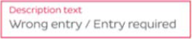.  - Where Description Text is the placeholder.  - “Wrong entry / Entry required” is the message content.
Error Message | - Pop-Up contains only message content and a button “Close”.  - Clicking outside of the pop-up does not close it, only button “Close” on the pop-up does.  - After closing popup, return to the current screen.  - Message is displayed when there is error in validation.
Confirmation Message | - Pop-Up contains only message content and two buttons “Yes”, “No”.  - Clicking outside of the pop-up does not close it, only button “Yes” or “No” does.  - After closing popup, performs the corresponding function or action, which is described specifically in each place using the Pop-up Confirmation Message.  - Message is displayed when there needs a confirmation of action.
Informing Message | - Pop-Up contains only message content and will disappear after 10s.  - Message is displayed after the system successfully performs a certain function or action.
Standard platform Message | - Any standard platform message can be presented here.

View Columns Display
<Template only: It is recommended that this part of the requirement refers directly to the library used by the development team, or get suggestions from design team. But in case those are not viable options, please use the following section>
Unless otherwise stated, view columns’ display specifications are:
- Displayed color & fonts are as specified in approved screen designs.
- When the text to be displayed is longer than the width of cell, cut the text at the end of first line, and replace the missing characters with “…”. Hovering mouse over this “…” will pop up a tooltip at mouse position that displays full content of the respective cell.
Unless otherwise stated, view columns’ headers are:
- Is unsorted by default.
- When unsorted, show icon as follows: 
- When sorted in ascending, show icon as follows: 
- When sorted in descending, show icon as follows: 

Pagination
<Template only: Parts of this segment will vary depends on pagination settings used by the current system. Please check and update accordingly>
Unless stated otherwise, pagination-related behavior in all views of the system will follow the following specifications:
- When user performs a new search (both completely new and searching within the current search results), refresh table, go back to page 1.
- When user changes the pagination setting (number of items to show per page), refresh table, go back to page 1.
- When user is in page 1, disable buttons of “<<” and “<”
- When user is in the last page, disable buttons of “>>” and “>”
- Otherwise, enable all buttons.
- Button “<” and “>” move the pagination backward or forward by 1.
- Button “<<” or “>>” move the pagination to page 1 or the last page.
- If there is 1 page, still display the pagination with 1 page.
- On the most left position, the system displays all records found that satisfied the current condition (display all or searched or filtered, etc…).
- User can input the number of pagination they want to go to, next to the total number of pagination.
- Sample: 

Search Component
<Template only: Parts of this segment will vary depends on search settings used by the current system. Please check and update accordingly>
Unless stated otherwise, search-related behavior in all views of the system will follow the following specifications:
- Search field is a Free Text (single line of text) field, thus it follows this field’s common properties.
- Search behavior follows “contain” logic, where the system searches all presenting columns for records that have value containing the keyed in value.
- Searched results are presented by refreshing the table listing information and the system updates pagination information accordingly.
- If keyed in value is blank, the system will reset to the default view information.

Bulk Action
<Template only: Parts of this segment will vary depends on Bulk Action settings used by the current system. Please check and update accordingly>
Unless stated otherwise, Bulk Action behavior in all views of the system will follow the following specifications:
- In the table listing, the first column will always be a checkbox columns allowing user to select records/items to apply Bulk Action.
- Selecting the checkbox on Column Header will select all checkboxes only on the current pagination of the table listing.
- Upon jumping between pagination, the selected state of checkboxes is kept.
- Users can select Bulk Action from the Dropdown list or available bulk action buttons (depending on the system) to apply to the selected items.
- For Dropdown list Bulk Action:
  - Bulk Action is the default option, which performs nothing when apply.
  - Value list contains:
    - Bulk Action.
    - Export.
    - Delete.
- For available bulk action buttons:
  - These buttons are enable only when at least 1 checkbox is selected.
  - Button includes:
    - Delete.
    - Export.

Integration
<Template only: Describe external system(s) which integrates with the system>

Data Migration
<Template only: Describe data migration scope and requirements.
In case SRS for data migration in a separated SRS, note down this point: e.g. Detailed requirements for Data Migration part will be described on separated SRS. The data migration SRS and the functional SRS will be a couple of documents to fulfil the whole requirements for SSS migration.>

Migration Scope
<Template only: This section is to define the scope of data migration. It contains the list of data objects or the specific condition to define the set of data which will be migrated.>

Data Mapping
<Template only: This section shows the mapping for migrated data. It contains the data properties on the old platform and the corresponding properties on the new platform. Data conversion and data patching rules are also described if any.>

Appendices

Messages List
<Suggestion of new presentation>
For description of Message Type, please refer to Common Messages Configuration.
# | Message Code and Content | Type
 | MSG 1 Vui lòng nhập thông tin | Error Message
 | MSG 2 You must specify a value for this required field. | Error Message
 | MSG 3 You must specify a value for this required field. | Error Message
 | MSG 4 You must specify a value for this required field. | Confirmation Message
 | MSG 5 You must specify a value for this required field. | In-line Error Message
 | MSG 6 You must specify a value for this required field. | Error Message
 | MSG 7 You must specify a value for this required field. | Confirmation Message
 | MSG 8 You must specify a value for this required field. | Error Message
 | MSG 9 You must specify a value for this required field. | Informing Message

Email Templates
<Template only: It is recommended that Email Template Contents are written in Past Tense instead of Present Tense to be more formal. Define any Prefix necessary for the Email>.
ET 1: Sending email to Evaluator when Suggester submits a Suggestion.
Send to | Evaluator
CC
Subject | [Prefix] SSS: A new Suggestion <<Suggestion Code>> has been submitted for your evaluation.
Body | Dear <<Evaluator’s name>>  The Suggestion <<Suggestion Code>> - <<Suggestion Title>> has been submitted for your evaluation.  To view the Suggestion details, please click here.  Sincerely,  SSS Admin  Note: This is an auto-generated email, please do not reply.
Note: The link here leads to screen <Reference here>.

